Ellene White Case Study Lesson Plan

Select a topic:
Endocarditis case study

Title:
A dental appointment gone wrong

Objectives:
- By the end of the post-conference, students will be able to:
  - Identify s/s of emergent situations regarding tachycardia, hypotension, fevers, pain management, and hypoxia.
  - Use critical thinking and identify interventions to do in emergent situations involving tachycardia, hypotension, fevers, pain, management, and hypoxia.
  - Explain why specific diagnostic testing is ordered concerning the patient’s presenting s/s.
  - Identify risk factors that put a patient at risk for endocarditis and pulmonary embolism.

Materials:
Conference room for post-clinical discussion + Copies of case study to hand out
Outline of case study:
Ellene White, 70 y/o F, Full Code, NKA
- C/O to ED: Flu-like symptoms (cough, runny nose, fatigued) and mild heaviness on the chest while breathing

- V/S
  - HR: 131 - BP: 125/91 - RR: 25 - T: 101.1 5F - O2 sat: 89%
  - 6/10 pain on fingers when you move joints

How do we treat the initial situation? What do you anticipate the doctor to order?
- Oxygen: NC to keep O2 sat above 93%
- Pain management: Oxycodone 5 mg to treat 6/10 pain in fingers
- High HR: Metoprolol 50 mg for high HR (131)
- IV Tylenol 1g to treat fever (101.5 F) and IV ceftriaxone (broad spectrum ABX) to prevent infection
- Medical hx:
  - HTN
  - Smoking
  - IV drug use
  - Root canal procedure 1 week ago

- Medication history
  - PO metoprolol 50 mg BID and PO lisinopril 10 mg BID for HTN
  - PO amoxicillin 500 mg BID for 3-7 days after root canal procedure
  - PO Ibuprofen 600 mg Q6 PRN for pain after root canal procedure

- Assessment:
  - NEURO: A&Ox4; relies on a walker for mobilization; weakness on BUE and BLE; pupils are equal and reactive; pleasant demeanor but states uncompliant with medications for root canal procedure
  - CV: No edema; pulses are palpable; S3 heart murmur
  - Resp: B/L sounds clear but diminished at bases
  - GI: BS present, obese belly, last BM was last night
  - GU: Continent of urine, clear and yellow urine
  - Skin: BUE bruising, red lesions on fingers

The doctor ordered dx testing. Why were they each ordered?:
- Blood Cx: S. aureus + - D/t high temp
- CBC: - D/t high temp
  - WBC: 14,000 (4,500-11,000)
  - Lactic acid: 4.5 mmol/L (3-4)
- Echocardiogram: TEE shows pulmonic valve vegetation – D/t murmur
- Troponin: Normal – D/t chest heaviness

The doctor determined his differential dx as infective endocarditis; the hospitalist decided that the patient would be admitted to the step-down unit.
Three hours after admission to the step-down unit, the doctor ordered a D-Dimer and a spinal CT. When you came back from spinal CT, Ms. White c/o:
- CP: 8/10
- SOB, lightheadedness, lethargic, and not responding
V/S:
- HR: 147 - BP: 89/40 - T: 101.5 F - RR: 32 – O2 sat: 87% on 4 L NC
- 8/10 pain that worsens with each breath

You decide to call a rapid response; how do we treat this situation before the rapid response team comes?
- Oxygen: 15 L NRB d/t low O2
- Fluids: 1L NS bolus d/t hypotension
  - Discuss passive leg raise
- Is pain a priority to treat? Why or why not? - No, b/c of hypotension

After fluid resuscitation, Ms. White’s BP is 90/41. Is this patient in septic shock?
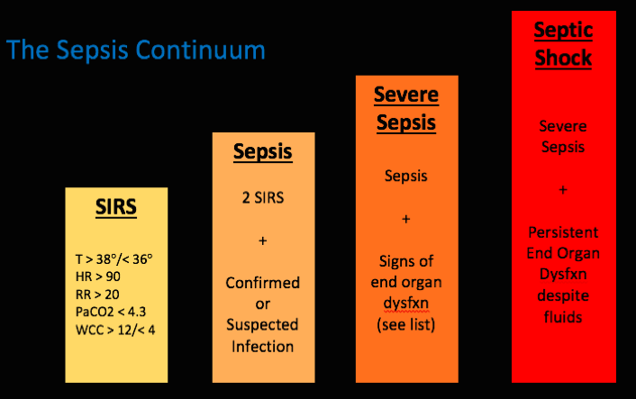
Yes! If a patient isn’t fluid-responsive? Pressors! ICU indication!
You noticed once the rapid response team arrived, Ms. White’s RR decreased to 7. The respiratory therapist, from the rapid response, drew an ABG. What can you interpret from the ABG?
pH: 7.29 - CO2: 70 - HCO3: 32 - PaO2: 70
Respiratory acidosis partially compensated by metabolic alkalosis
- What drove the CO2 up? Hypoventilation

Is this patient a candidate for going to the ICU? – Yes, his ABG and status indicate emergent intubation
When you go to chart your patient, the results from your D-Dimer and spinal CT scan come back:
- D-Dimer: Positive
- Spinal CT scan: Positive for blood clots
The ICU doctor then diagnoses the patient with pulmonary embolism; what risk factors led to the pulmonary embolism?
- ****Infective endocarditis vegetation lodged off as a clot
  - IV drug use
  - Root canal procedure 1 week ago
  - Uncompliant with medications
How do we treat pulmonary embolism? Is thrombolytics an option?
- Oxygen
- Heparin drip!
- No thrombolytics d/t recent procedure on a root canal.

Planned evaluation of learning:
Actively discuss with the clinical group by asking the students engaging questions highlighted in red and points in italics/bold in the outline. Help guide their brain by asking questions to help them breakdown what got them to their conclusions.
- Ex: Why should we give oxygen? Why should we administer heparin?

